Dear families,

Attached are lessons, worksheets, books, and simple conversation starters for you to engage with your child during this time of home instruction.

We are beginning a new study on Restaurants so a lot the materials and the stories will focus on different types of food and restaurants. In our classroom, when we return, we will be creating a Pizzeria for our Dramatic Play center. Some of the activities will focus on pizza.

I hope you enjoy this time with your child and take the time to engage in these activities together. If some of the lessons require you print or use materials that you may not have, there are always options to complete the activity.

I hope you all stay safe and healthy! I am only an email away if you have any questions regarding the packet sent home or the lessons uploaded here.

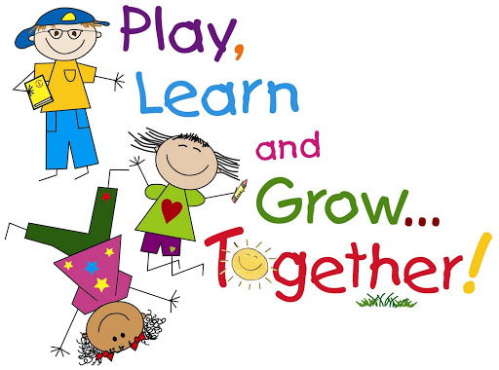Respectfully,

Mrs. Carmon